**Introduction to HTML/CSS**

**1.**How are inline and block elements different from each other?

**Ans- Inline element** does not cause a line break (start on a new line) and does not take up the full width of a page, only the space bounded by its opening and closing tag. It is usually used within other HTML elements.

Some examples of inline elements are:

* anchor <a> tag
* emphasis <em> tag
* image <img> tag

**Block element** always starts on a new line and takes up the full width of a page, from left to right. A block-level element can take up one line or multiple lines and has a line break before and after the element.

Some examples of the block-level tag are:

* Heading tags <h1> to <h6>
* List (Ordered, Unordered, Description and List Item) tags <ol> , <ul> ,<dl> , <li>
* Blockquote tag <blockquote>

**2**.Explain the difference between visibility:hidden and display:none

**Ans- Display:none** means that the tag in question will not appear on the page at all (although you can still interact with it through the dom). There will be no space allocated for it between the other tags.

-removes the element from the normal flow of the page, allowing other elements to fill in.

**Visibility:hidden** means that unlike display:none, the tag is not visible, but space is allocated for it on the page. The tag is rendered, it just isn't seen on the page.

-leaves the element in the normal flow of the page such that is still occupies space.

**3.**Explain the clear and float properties.

**Ans- Float property** specifies how an element should float.

-it is used for positioning and formatting content e.g. let an image float left to the text in a container.

The float property can have one of the following values:

* left - The element floats to the left of its container
* right- The element floats to the right of its container
* none - The element does not float (will be displayed just where it occurs in the text). This is default
* inherit - The element inherits the float value of its parent

In its simplest use, the float property can be used to wrap text around images.

**Clear property** specifies what elements can float beside the cleared element and on which side.

-it specifies what elements can float beside the cleared element and on which side.

The clear property can have one of the following values:

* none - Allows floating elements on both sides. This is default
* left - No floating elements allowed on the left side
* right- No floating elements allowed on the right side
* both - No floating elements allowed on either the left or the right side
* inherit - The element inherits the clear value of its parent

The most common way to use the clear property is after you have used a float property on an element.

**4.**explain difference between absolute, relative,fixed and static.

**Ans-** The **position** property specifies the type of positioning method used for an element.

There are different position values:

* static
* relative
* fixed
* absolute

**Static-** HTML elements are positioned static by default. Static positioned elements are not affected by the top, bottom, left, and right properties.An element with position: static; is not positioned in any special way; it is always positioned according to the normal flow of the page:

div.static {

position: static;

border: 3px solid #73AD21;

}

**Relative**-An element with position: relative; is positioned relative to its normal position.Setting the top, right, bottom, and left properties of a relatively-positioned element will cause it to be adjusted away from its normal position. Other content will not be adjusted to fit into any gap left by the element.

div.relative {

position: relative;

left: 30px;

border: 3px solid #73AD21;

}

**Fixed-**An element with position: fixed; is positioned relative to the viewport, which means it always stays in the same place even if the page is scrolled. The top, right, bottom, and left properties are used to position the element.A fixed element does not leave a gap in the page where it would normally have been located.

div.fixed {

position: fixed;

bottom: 0;

right: 0;

width: 300px;

border: 3px solid #73AD21;

}

**Absolute-**An element with position: absolute; is positioned relative to the nearest positioned ancestor (instead of positioned relative to the viewport, like fixed).However; if an absolute positioned element has no positioned ancestors, it uses the document body, and moves along with page scrolling.

div.absolute {

position: absolute;

top: 80px;

right: 0;

width: 200px;

height: 100px;

border: 3px solid #73AD21;

}

**5.**Write the HTML code to create a table in which there are 4 columns( ID , Employee Name, Designation, Department) and at least 6 rows. Also do some styling to it.

**Ans-**

<!DOCTYPE html>

<html>

<head>

<style>

table {

font-family: arial, sans-serif;

border-collapse: collapse;

width: 100%;

}

td, th {

border: 1px solid #dddddd;

padding: 8px;

}

</style>

</head>

<body>

<h2>MyTable</h2>

<table>

<tr>

<th>ID</th>

<th>Employee NameSec</th>

<th>Designation</th>

<th>Department</th>

</tr>

<tr>

<td>1</td>

<td>Vinni</td>

<td>CEO</td>

<td>ComputerScience</td>

</tr>

<tr>

<td>2</td>

<td>Gagan</td>

<td>COO</td>

<td>ComputerScience</td>

</tr>

<tr>

<td>3</td>

<td>Satya</td>

<td>Project Manager</td>

<td>ComputerScience</td>

</tr>

<tr>

<td>4</td>

<td>Sai</td>

<td>Manager</td>

<td>ComputerScience</td>

</tr>

<tr>

<td>5</td>

<td>Pankaj</td>

<td>tester</td>

<td>ComputerScience</td>

</tr>

<tr>

<td>6</td>

<td>Kumar</td>

<td>Developer</td>

<td>ComputerScience</td>

</tr>

<tr>

<td>7</td>

<td>Vishnu</td>

<td>Developer</td>

<td>ComputerScience</td>

</tr>

</table>

</body>

</html>

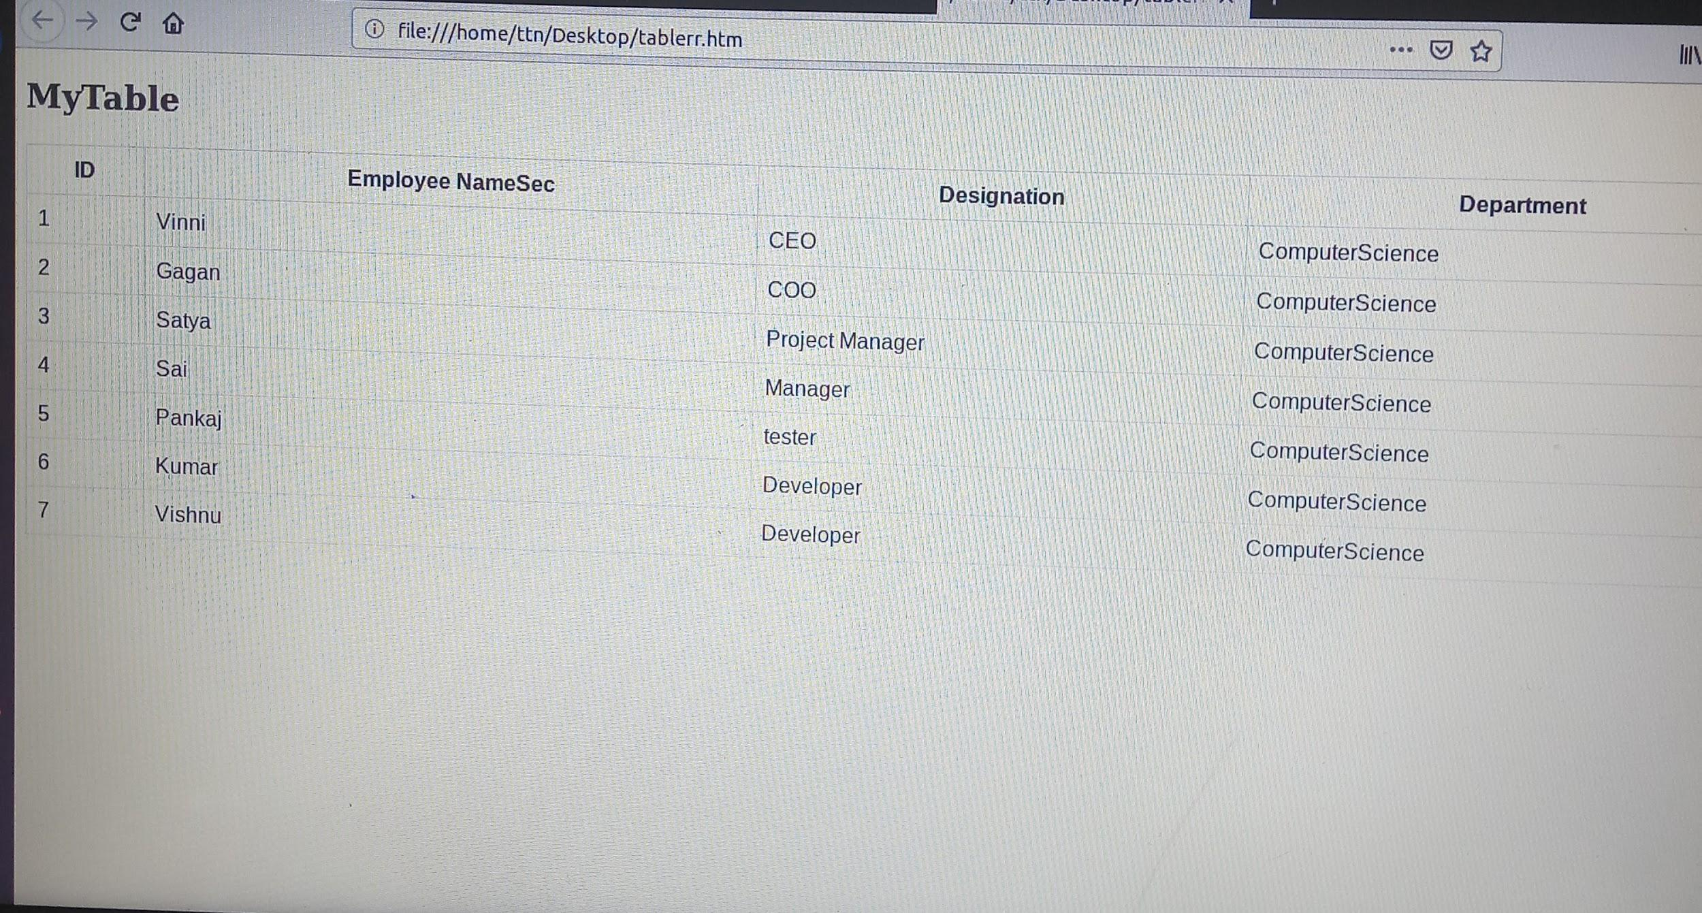

**6.**Why do we use meta tags?

**Ans-** Metadata is data (information) about data.

The <meta> tag provides metadata about the HTML document. Metadata will not be displayed on the page, but will be machine parsable.

Meta elements are typically used to specify page description, keywords, author of the document, last modified, and other metadata.

The metadata can be used by browsers (how to display content or reload page), search engines (keywords), or other web services.

HTML5 introduced a method to let web designers take control over the viewport

<head>

<meta charset="UTF-8">

<meta name="description" content="Free Web tutorials">

<meta name="keywords" content="HTML,CSS,XML,JavaScript">

<meta name="author" content="John Doe">

<meta name="viewport" content="width=device-width, initial-scale=1.0">

</head>

**7.**Explain box model.

**Ans-** All HTML elements can be considered as boxes. In CSS, the term "box model" is used when talking about design and layout.The CSS box model is essentially a box that wraps around every HTML element. It consists of: margins, borders, padding, and the actual content.

* **Content** - The content of the box, where text and images appear
* **Padding** - Clears an area around the content. The padding is transparent
* **Border** - A border that goes around the padding and content
* **Margin** - Clears an area outside the border. The margin is transparent

The box model allows us to add a border around elements, and to define space between elements.

**8.**What are the different types of CSS Selectors?

**Ans-** CSS selectors are used *to* select the content you want to style.CSS selectors select HTML elements according to its id, class, type, attribute etc.

There are several different types of selectors in CSS.

* **CSS Element Selector**-The element selector selects the HTML element by name.

Ex- p{//css code}

* **CSS Id Selector**-The id selector selects the id attribute of an HTML element to select a specific element. An id is always unique within the page so it is chosen to select a single, unique element.It is written with the hash character (#), followed by the id of the element.

Ex- #para1 { //css }

* **CSS Class Selector**-The class selector selects HTML elements with a specific class attribute. It is used with a period character . (full stop symbol) followed by the class name.

Ex- .center { //css }

* **CSS Universal Selector-**The universal selector is used as a wildcard character. It selects all the elements on the pages.

Ex- *{//css}

* **CSS Group Selector-** The grouping selector is used to select all the elements with the same style definitions.Grouping selector is used to minimize the code. Commas are used to separate each selector in grouping.

Ex- h1,h2,p { //css}

**9.**Define Doctype.

**Ans-** DOCTYPE declaration must be the very first thing in your HTML document, before the <html> tag.it is an instruction to the web browser about what version of HTML the page is written in.

In HTML 4.01, the <!DOCTYPE> declaration refers to a DTD(document type definition), because HTML 4.01 was based on SGML. The DTD specifies the rules for the markup language, so that the browsers render the content correctly.HTML5 is not based on SGML, and therefore does not require a reference to a DTD.

**10.**Explain 5 HTML5 semantic tags.

**Ans-** A semantic element clearly describes its meaning to both the browser and the developer.

**-Non-semantic** elements: <div> and <span> - Tells nothing about its content.

**-Semantic** elements: <form>, <table>, and <article> - Clearly defines its content.

5 HTML semantics tags example:

<article>-The <article> element specifies independent, self-contained content.

<footer>- It typically contains the author of the document, copyright information, links to terms of use, contact information, etc.

<header>- It specifies a header for a document or section.

,<nav>-It defines a set of navigation links.

<section>-A section is a thematic grouping of content, typically with a heading.

**11.**Create HTML for web-page.jpg (check resources, highest weightage for answers)

**Ans-** Code file is attached(https://drive.google.com/open?id=1cuQGpWL9NmQzZi8GcgXzgZIot0Hf7WBj) 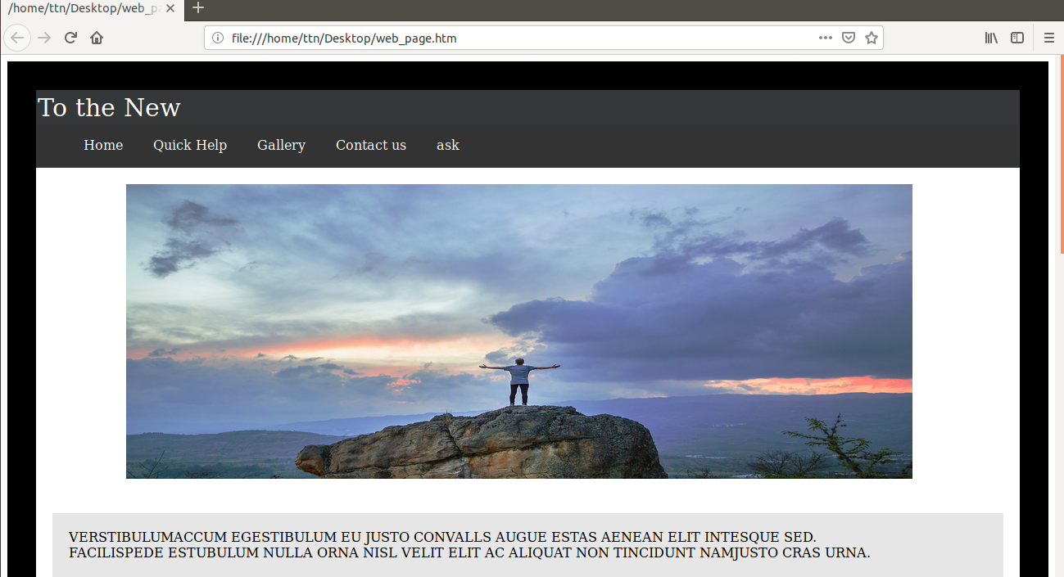

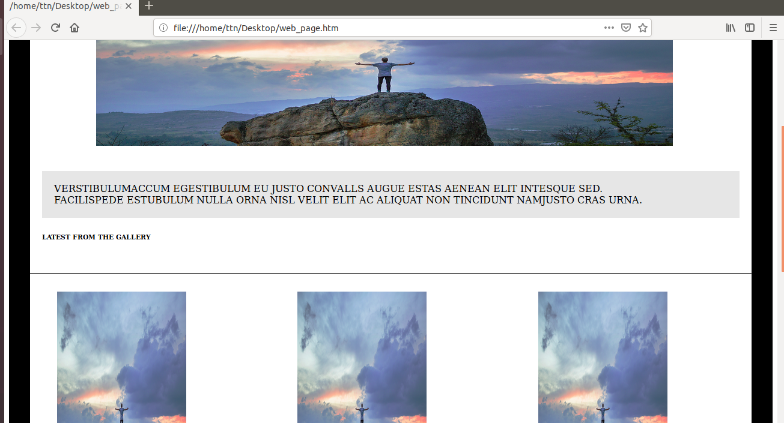

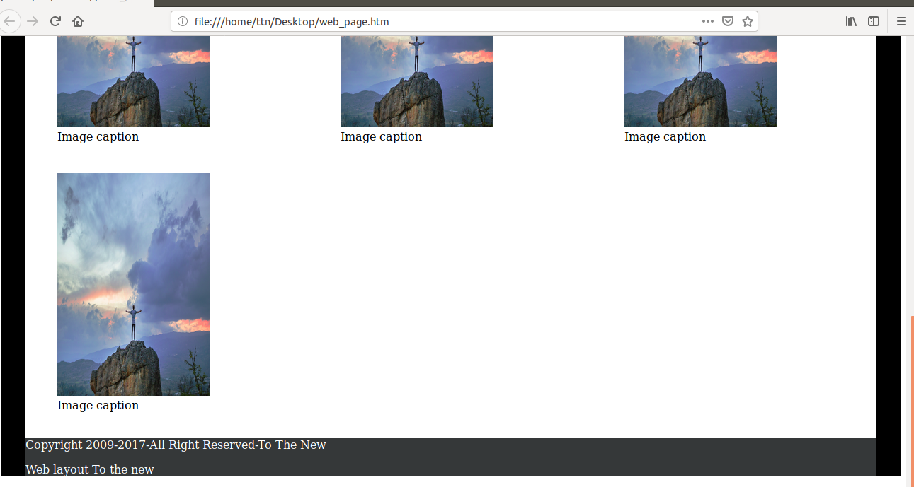

**12-**Create HTML for form.png (check resources, highest weightage for answers)

**Ans-** Code file(https://drive.google.com/open?id=18q7DOW7GqZUgXIXSJBHlf38Z9Csex533)

